**Lab Report #1 – Wall Following**

Group #55: Alex Hale (260672475) and Xianyi Zhan ()

ECSE 211 – Design Principles and Methods

September 21, 2017

Design Evaluation

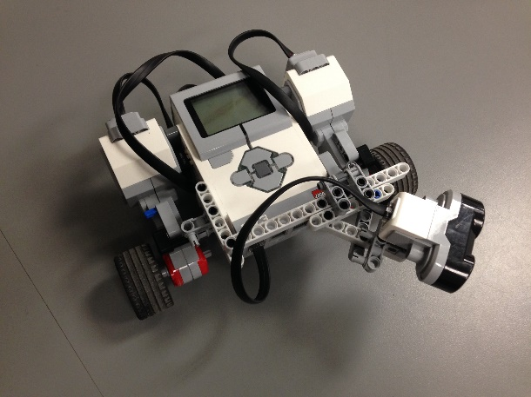Hardware

A simple three-wheeled robot was created using two motors, two wheels, one ball bearing, one ultrasonic sensor, one EV3 brick, and various connecting pieces. The ultrasonic sensor was mounted to the left front corner of the robot, above the left wheel, at a 55o angle forward from perpendicular to the wall.

Software

The software structure was unchanged from the code provided.

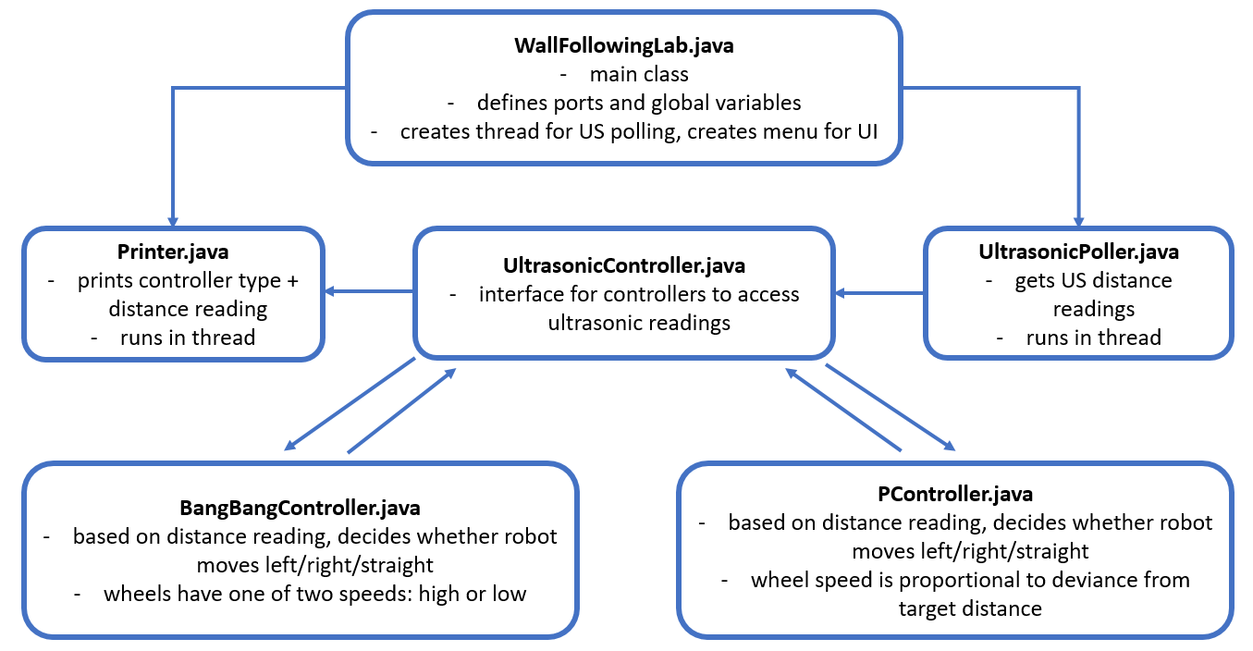

Workflow (hours are a total of both lab partners)

1. Design robot based on given criteria (2 hours)
2. Fill in software framework code based on controller type and design criteria (2 hours)
3. Test design on course of wooden blocks. Identify errors in hardware and software that cause the robot to fail the design criteria, fix them, repeat (10 hours)
4. Demo project to TA (0.5 hours)
5. Lab report (3 hours)

Test Data

Bang-Bang Test

|  |  |  |
| --- | --- | --- |
| **Trial #** | **Completed lap?** | **Band Center / Oscillation Behaviour** |
| 1 | Y | Followed wall well if started at a distance equal to band center. Oscillated after completing a corner and readjusting to meet the bandcenter. |
| 2 | N | Turned too tight at the end of the track, hit the wall behind the ultrasonic sensor and in front of the front wheel (the “blind spot”). |
| 3 | Y | Cut concave corners instead of approaching the forward wall and making a sharper turn. Due to orientation of sensor, oscillated when moving from close to the wall out to the bandcenter. When moving from far from the wall in to the band center, approached smoothly. |

P-Type Test

|  |  |  |
| --- | --- | --- |
| **Trial #** | **Completed lap?** | **Band Center / Oscillation Behaviour** |
| 1 | N | Due to the high filter value, moved too far away from wall before accepting a high US measurement. Once it started turning back, it was going the wrong direction. |
| 2 | Y | Completed lap around the track, but the proportionality constant was too low and the robot did a circle around the entire track instead of following the wall at the band center distance. |
| 3 | Y | Oscillated while moving away from the wall because the robot was turning and alternating between distance readings (robot faced forward <-> sensor facing 55 degrees). Moving from far away to the band center, the proportionality constant should have been higher. |

Test Analysis

Both controllers kept the robot at a fixed distance from the wall in straight sections, but struggled to do so around corners.

When using the bang-bang controller, the robot got very close to the wall around 180o corners. The robot then started the next straightaway very close to the wall and oscillated when moving out toward the band center. Once the robot reached the band center, it was generally quite stable and did not oscillate too much. However, there was not a section of wall long enough to test this completely: the robot usually arrived at the next corner before settling on to the band center.

When using the p-type controller, the robot was usually quite far from the wall around 108o corners. This occurred because there was a maximum difference between allowed the speeds of the wheels, preventing the robot from turning too sharply due to erroneous ultrasonic measurements. This large berth around corners meant that the robot successfully completed laps on a more regular basis than the bang-bang controller, but those laps were usually completed at a lengthy distance from the wall.

In general, the robot experienced very little oscillation from one side of the bandcenter to the other, for two reasons. Firstly, we enlarged our bandwidth to 4 cm (2 cm on each side of the bandcenter), making the robot correct less often. Secondly, the course was made up of mostly turns, during which the robot was not on the bandcenter, so oscillation didn’t often occur. The robot was tracking toward the band center nearly the entire lap. This result was observed for both controllers.

Observations and Conclusions

The ultrasonic sensor experiences fewer errors than expected. Most errors were caused by the fact that the sensor was mounted at an angle. There was some delay between the sensor reading and the processing of the reading, but this was mitigated by lowering the robot’s speed.

In testing, the ultrasonic sensor only experienced occasional false positives. The controllers both had a “very close, move away” condition that activated when the robot got much too close to the wall. To avoid the robot turning away from the wall due to a false positive, a simple filter was implemented that required at least two consecutive readings of below 20 cm (since the sensor was mounted at 55 degrees, this meant that the robot was at a distance of $20 cm*\cos\left({55}^{o}\right)=11.47 cm$) before turning away quickly.

The ultrasonic sensor experienced more false negatives than false positives. It is believed that this occurred since the sensor was mounted at an angle, meaning many of the ultrasonic chirps would reflect away off the wall and not return to the sensor. Due to false negatives, the robot was more frequently too close to the wall than too far away. To filter out false negatives, we required 35 readings of 255 cm (maximum distance) readings before accepting that there was really nothing there.

Further Improvements

1. The robot hardware could have been built to be more stable and compact. The wheelbase was too wide and the connection to the brick was too flexible, making the robot slightly instable. With the performance requirements of this lab there were no issues with this construction, but in future labs more precise measurement will be required, meaning a more stable robot is necessary.
2. The use of a second ultrasonic sensor would make enormous performance improvements. One sensor could be mounted to the front to take measurements of any oncoming walls, and the other sensor could be mounted to the side to take measurements of the wall that the robot is currently following. With this sensor configuration, the robot could follow the wall at the same distance throughout the lap instead of cutting some corners. Corner-cutting occurred when the sensor was sensing multiple walls at the same time. This configuration would also allow for more precise filtering of gaps in the wall.
3. The filter for gaps in the wall could be lowered. It was set very high (35 readings) due to prior difficulties filtering gaps while the robot was turning, but this meant that the robot made very wide 180o turns. This wide turn almost never stopped the robot from completing the lap, but it did not stay at the proper band center distance throughout the lap.
4. The printer could have been modified to present both the ultrasonic sensor reading *and* the robot’s actual distance from the wall (i.e. $US reading*cos⁡({55}^{o})$), making debugging easier.
5. The robot could have sent ultrasonic readings and motor speed data back to the computer and that data could have been logged for debugging purposes.

Another controller type that could be used is a Proportional, Integral, Derivative (PID) controller, where the speed of the wheels is proportional to the speed at which the robot is approaching or departing the bandcenter. This way, the robot could smoothly achieve bandcenter distance without overshooting it and having to make another correction.